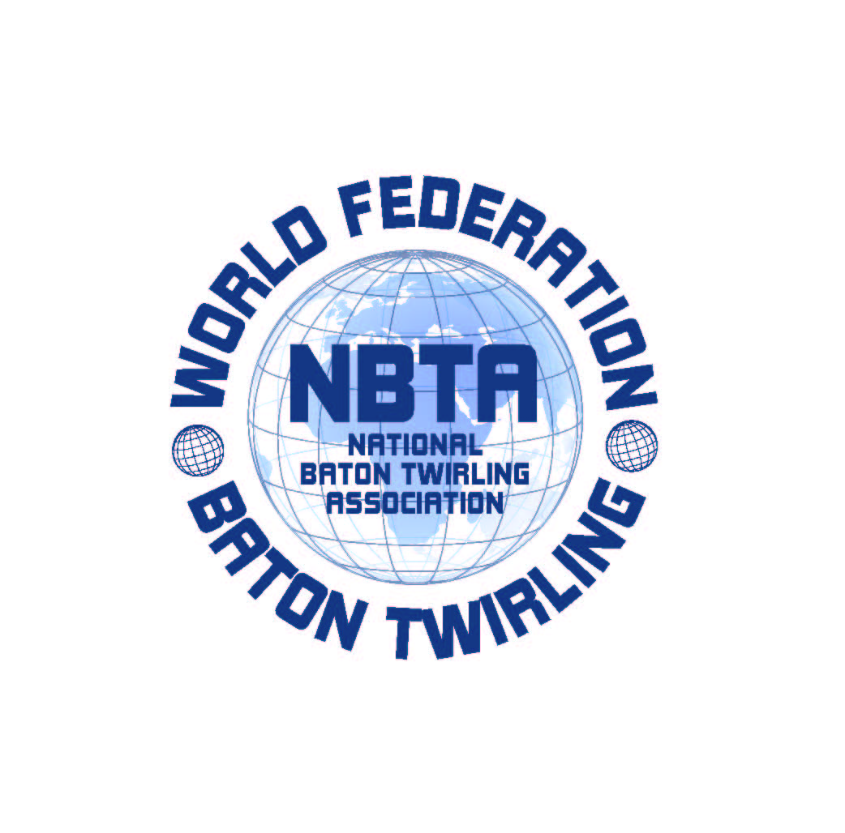

SEDE: V.le Risorgimento n°21 -26017-Trescore Cremasco (CR)
Tel.0373 / 274851 Fax 0373/291336
P. IVA 01119000196
MAIL: info@nbtaitalia.com
WEB: www.nbtaitalia.com

ASSOCIAZIONE NAZIONALE BATON TWIRLING
Dal 1983 membro della NBTA Europa e della World Federation W.F.N.B.T.A.

RESERVATION FORM
For DAILY EXTRA LUNCH AND DINNER
(only for those overnight staying outside the Village Ge.Tur.)

LUNCH DINNER Total
N. Persons N. Persons

October, 3rd Green _______ _________ ________

October, 4th Pink _______ _________ ________

Extra Lunch or Extra Dinner costs €12,00 each one per day.

To confirm the reservation, please make payment in advance by bank transfer on:
Swift Code: BAPPIT21R33
Iban Code: IT61Q 05034 57260 000000165425

Send your reservation by e.mail at info@nbtaitalia.it , attaching this completed form and the receipt of payment bank.

